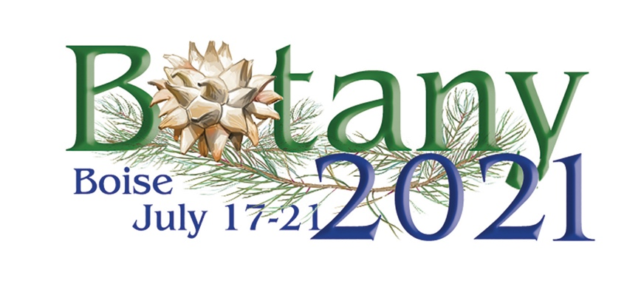
Botany 2021 – Boise!
Update on the Convention Centre and COVID
Revised - November 19, 2020

Information from the Director of Sales of Boise Centre
- They are still at the state recommended 50 people per room limit. They have approximately 30 meeting rooms throughout the venue and they have sent me floor plans of how the room sets will look. Up to this point the largest conference they have had inhouse is 250.
- GBAC Star Accreditation – Boise Centre has submitted its application for accreditation and is listed as a committed facility. Receiving the STAR Accreditation will mean that Boise Centre has demonstrated the following:
  - Established and maintained a cleaning, disinfection, and infectious disease prevention program to minimize risks associated with infectious agents like the novel coronavirus (SARS-CoV-2).
  - The proper cleaning protocols, disinfection techniques, and work practices in place to combat biohazards and infectious disease.
  - Highly informed cleaning professionals who are trained for outbreak and infectious disease preparation and response.
- Boise Centre has equipped itself with three mobile thermal cameras that can be positioned at controlled entry points. These thermal cameras can take the temperature of up to 3 people per second. In addition, cleaning and disinfecting tools such as electrostatic sprayers and products meeting EPA guidelines for use against the virus that causes COVID-19 are routinely used throughout the facility. Currently they have a building-wide disinfectant system that kills the virus on surfaces for up to 30 days. The conference would have to hire a Security team to monitor the scanners. If someone had a temp of greater than 100° F they would be taken to a nearby office and the event organizer would have to deal with the situation.
- With the announcement of the potential vaccine they are feeling very hopeful for next summer. Apparently, they are on track for being one of the first vaccine distribution sites in the country – criteria being high incidences of infection and a proper cold storage facility
Directly related to the Conference Expenses
- The Centre has agreed to work with us to reduce the food and beverage minimums and room rentals if we have a reduction in attendance. Currently we are entitled to free rental of the meeting space if we spend $125,000 in Food & Beverage and occupy 1600 room nights (very conservative in a “normal” year!).
- On our recent call with the CVB, the Centre and Hotel representatives we have agreed that Botany would not cancel the conference but postpone it to the next open year if necessary…most likely 2024. Without this agreement and if we canceled the conference completely, we would owe the Centre $84,000. This agreement is a win-win for both of us. We will work to get this in writing.
These are the cancelation penalties and dates we would have owed IF the decision is made to outright cancel:
  - 6 months before the conference – January 15, 2021 - $42000.00 – 50% of total fees
  - 3 months or less than 6 – May 17 - $63, 000 – 75% of total fees
  - 3 months or less – Any time after May 17 –$84,000 - 100% of total fees
Once we have this agreement in writing we will not have any cancellation penalties. Any deposits we have paid will be rolled over to 2024.
- We have been in touch with the hotels where we have room blocks. We already have no attrition with all of them and in addition they have agreed to waive cancelation charges. This means that if an attendee makes a reservation and then at the last minute decides to cancel, they will not be charged a fee – usually a one-night room rate penalty. This is beneficial to our attendees.
House Bill 500 – Idaho’s Discriminatory Anti-Transgender Law
- Currently there is an injunction against the law – and enforcement will be suspended while litigation is pending. Hopefully, this will make it possible for attendees to participate in the conference from states such as California.
- I have a press release and two letters to support Boise Tourism that I can share.
Next Steps
- Determine what a hybrid conference could look like given the size of the Centre and the program. Layout and costs. I have an initial conversation pending with the Centre’s AV and IT folks. I hope to have a budget put together by mid-December,
- Determine our go-no go date. Considering how quickly we were able to produce Botany 2020 – I propose putting the decision off as long as possible. I would like input from Board members and also from our Society partners.

Future Botany Conferences

Botany 2021 – Boise, Idaho July 17 – 21, 2021
Botany 2022 – Anchorage, Alaska July 24 – 27, 2022
Botany 2023 – Most likely a virtual conference due to the International Botanical Congress in Brazil.
Botany 2024 –
Botany 2025 – Tucson, Arizona July 25 – 30, 2025

