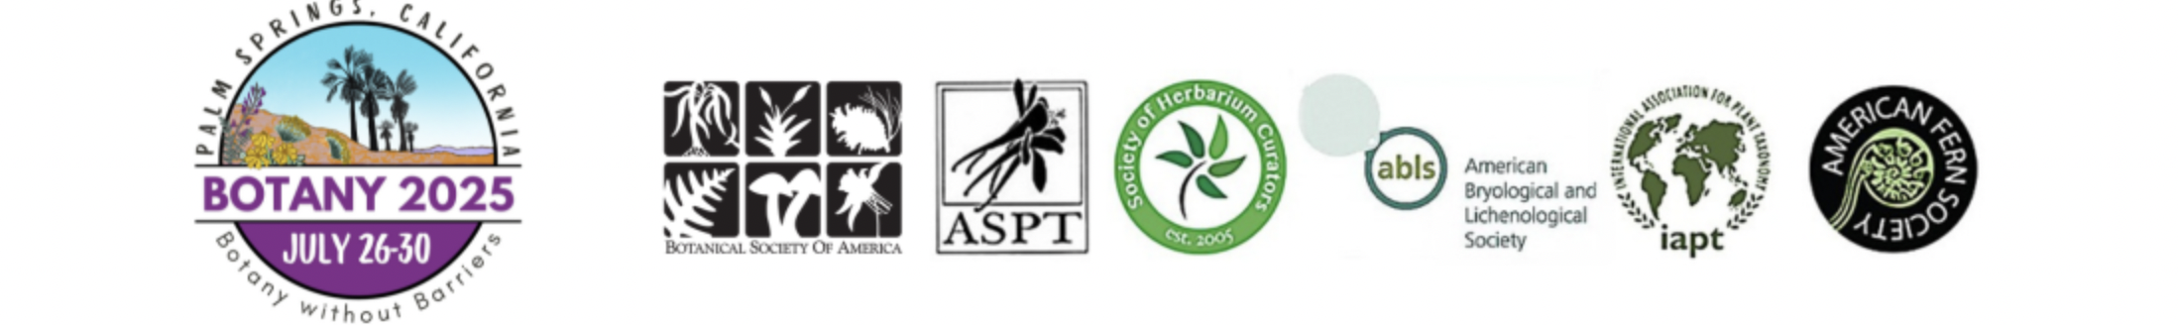
Conference Website Reorganized and Revised for cleaner look (Thanks Amelia!) https://www.botanyconference.org/
13 Workshops (combination of 2-hour, half-day and full day); cost for workshops $25-$70 to cover AV, coffee breaks, room costs
8 Field Trips for Saturday/Sunday getting finalized by our California team of Amy Litt, Naomi Fraga, Lucinda McDade and Josh Der
- Mt. San Jacinto, James Reserve and other areas
- Mt. San Jacinto, Tramway to Hidden Lake
- San Bernardino Mtns, Mountain Meadows
- San Bernardino Mtns, Oak Glen Preserve
- Whitewater Preserve
- Joshua Tree National Park
- Fern Foray
- Bryo/Lichen Trip organized by ABLS
- Potential California Botanic Garden
- Potential Living Zoo and Gardens

Registration Rates Posted / Registration Open https://www.botanyconference.org/registration-rates.html
- Slight increase to registration rates
- Due to rising costs for AV and Food and Beverage, the program committee had to make hard decisions about offerings
- Registration includes morning coffee breaks M,T,W (no snacks and no continental breakfast). If registration revenue is higher than expected, we could add snacks back in.
- Will support food insecure students with gift cards to walkable grocery store “Botany Eats” program
- Made Closing Reception a ticketed item

Sponsors/Exhibitors
New Prospectus and personal outreach seems to be working. Attracting some new companies! New this year – Academic Displays for Colleges/Universities - $200!

